SQL TEST
PART 1
From the data, write the SQL query to (using MySQL syntax):
- Show a list of only the second last transactions from each vendor
- Count the transactions from each vendor with the status CANCELLED per day
- Show a list of customers who made more than 1 SHIPPED purchases
- Show the total transactions (volume) and category of each vendor by following these criteria:
  - Superb: More than 2 SHIPPED and 0 CANCELLED transactions
  - Good: More than 2 SHIPPED and 1 or more CANCELLED transactions
  - Normal: other than Superb and Good criteria
Order the vendors by the best category (Superb, Good, Normal), then by the biggest
transaction volume
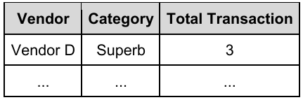
- Group the transactions by hour of transaction_date
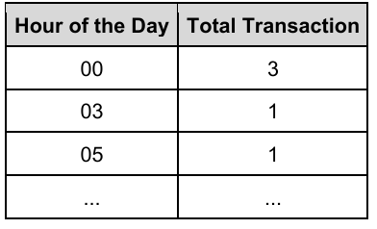
- Group the transactions by day and statuses as the example below
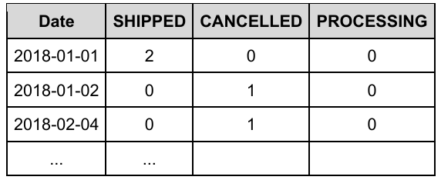
- Calculate the average, minimum and maximum of days interval of each transaction (how many days from one transaction to the next)
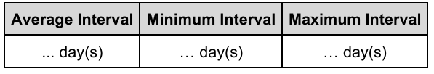

PART 2
The new table, “transaction_details” contains the details of purchased item of each transaction in “transactions” table.
In reference to both tables, write an SQL query to:
- Show the sum of the total value of the products shipped along with the Distributor Commissions (2% of the total product value if total quantity is 100 or less, 4% of the total product value if total quantity sold is more than 100)
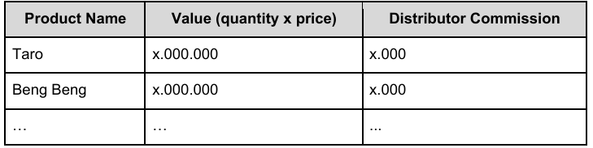
- Show total quantity of “Indomie (all variant)” shipped within February 2018
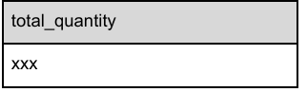
- For each product, show the ID of the last transaction which contained that particular product
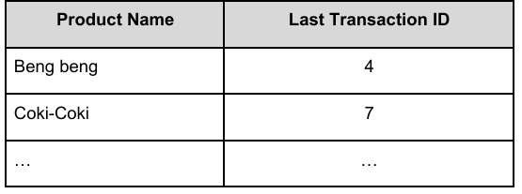
PART 3
The new table, “tracking” contains the details of customer’s activity from the “transactions” table.
- The company deployed several new features in the latest app version. You are tasked to figure out if these new features are beneficial to the company. Please identify and explain the metrics you are going to use to prove the new feature’s
usefulness. You are free to decide on the metrics and can use all 3 tables as reference. Please write the SQL to show the metrics and the results of the query.
- One of the metrics should show a funnel.

